Tech Tips: Screencast-O-Matic – An Easy, Affordable Way to Record Screencasts
by Stacy Stone on June 15, 2012 in Technology Tips
Yesterday, a friend called me right before throwing her computer out the window, extremely frustrated because she had spent over an hour recording the perfect screencast for her upcoming class…only to find out that she had video, but no audio. Grr!
Most of us who teach classes often probably already have Screenflow orCamtasia…but there are times when knowing about an affordable backup solution could be very helpful (especially if you’re 2 seconds away from throwing your computer out the window like my friend was!). I talked her out of trashing her computer, and into using the tool we’re discussing today: Screencast-O-Matic. It is, quite simply, a tool to record your screen and audio. It’s cheap, easy to use, and effective. There’s not even a program to install!
It’s free to sign up for a Screencast-O-Matic account, but you’ll be limited to 15 minute recordings with a watermark (which would be okay if you’re only using it for team training or internal screencasts). However, $15 a year will get you a pro account with unlimited recordings, no watermark, editing tools, script tools, additional recording controls and the ability to use the tool outside of your browser.
Once you log in, you’re presented with two self-explanatory options: Start Recording and Open Pro Tools. You’ll need to allow the JAVA applet to run, but otherwise the startup was flawless on my Mac. Clicking “Start Recording” launches the app, and you have the option to resize the screen, change the number of screens per second and turn on the webcam before you hit record. Once you’ve hit record you can’t change or move the screen, so make sure it’s in the right place!
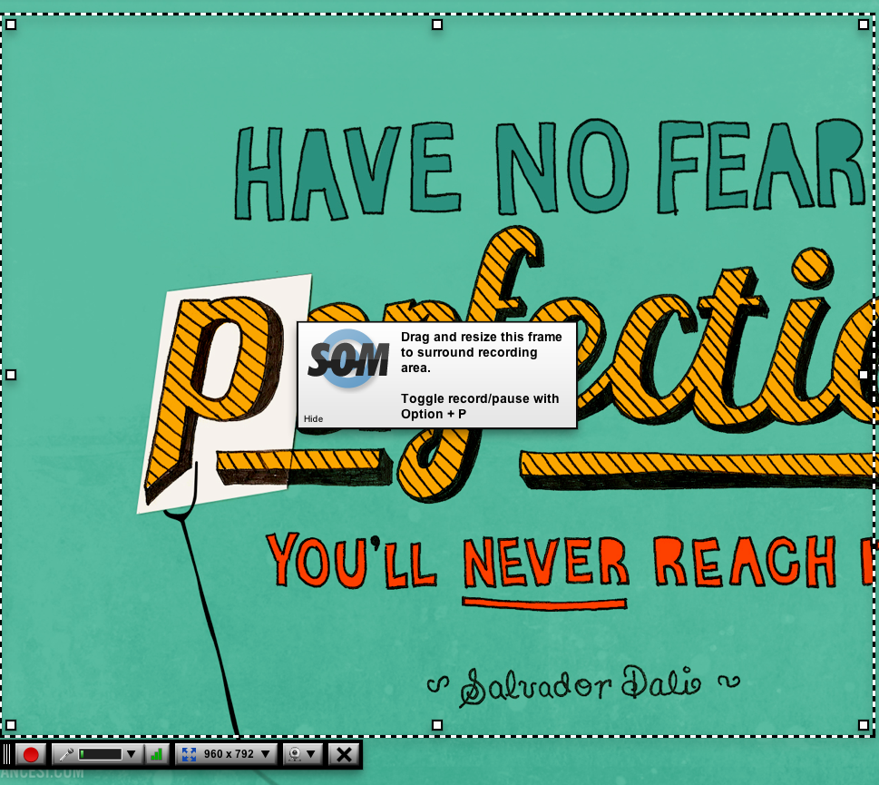
Here are the recording controls.
Once you’re done, hit the Done button and you’ll be automatically redirected to the Screencast-O-Matic app where your file is processing. You can make basic edits – crop, cut out sections, zoom, pan, change the speed of playback and edit the audio. Then you can export to YouTube, Mp4, Google Docs or to screen shots using the options under the Publish menu on the right.
Bottom line: Screencast-O-Matic does exactly what it says it will, and it’s affordable. I think it’s a great backup option to have in your arsenal…plus you have the bonus of feeling geeky and sci-fi. “Arthur, fire up the Screencast-O-Matic!”

